**University of Management and Technology, Lahore Campus**

**Lab- 02 Manual**

Lab Instructor: Riaz Ahmad

Department of Computer Science

Email: [riazahmad@umt.edu.pk](mailto:riazahmad@umt.edu.pk)

## **Table of Contents**

**Table of Contents** 1

2.1 Objective: 2

2.2 Scope: 2

2.3 Useful Concepts: 2

2.4 Examples 3

2.5 Lab Exercise: 7

2.6 Home Work: 7

**Lab # 02**

**Single Line Comment, Multi line Comment, *cout* and *cin* Statements**

### Objective:

To familiarize the students with the use of single line comment, multi line comment ***cout*** and ***cin***

statements.

### Scope:

The student should know the following at the end of this lab:

1. Problem Solving
2. How to use ***cout*** and ***cin*** statements
3. Single & Multi line comments
4. Invalid nesting of multi line comments
5. Writing Complete Programs

### Useful Concepts:

* + - *cout*

The statements ***cout*** is used to print the “character, string, float, integer, octal and hexadecimal values” onto the output screen.

* + - *Escape character (\)*
      * Special characters used to control the format of the output.
      * Characters are not displayed in the output.
      * Always begin with backslash "\".
      * backslash ( \ ) is called an escape character.

1 2 3 4 5

6 7 8 9 10

Pakistan is my country

Islamabad is its capital

*

* *

* * *

* * * *

|  |  |
| --- | --- |
| **Escape Sequences** | **Character** |
| \b | Backspace |
| \f | Form feed / new page |
| \n | Newline |
| \r | Return |
| \t | Horizontal tab |
| \v | Vertical tab |
| \a | Alert |
| \\ | Backslash |
| \' | Single quotation mark |
| \" | Double quotation mark |
| \? | Question mark |
| \0 | Null character |

* + - *cin*

The statements ***cin*** obtains a value from the user using standard input (usually keyboard) When executing the program the user responds to the ***cin*** statement by typing in a character from keyboard, then pressing the enter (return) key. A variable is used to store the entered value.

**Single line comments**

* + - * Text after // till next line is ignored by computer
      * Used to describe program

**Multi line comments**

* + - * Text surrounded by /* and */
      * Used to describe program

### Examples

**Example 2.1:** This program demonstrates the use of ***cout*** and the basic structure of a C++ program.

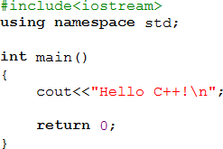

Here’s the program’s output:

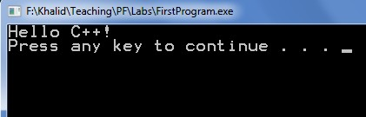

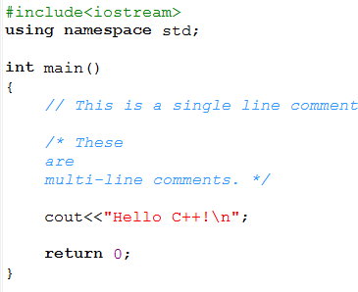**Example 2.2:** This program illustrates the use of single line (//text) and multi line comments (\* text *\).

Here’s the program’s output:



**Example 2.3:** This program illustrates the use of nested multi line comments in ***cout*** statements.

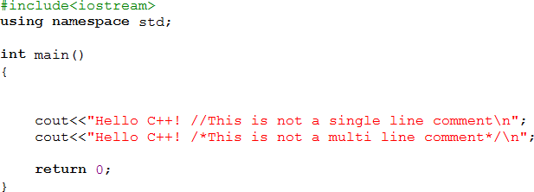

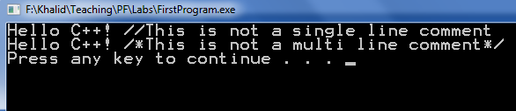Here’s the program’s output:

**Example 2.4:** This program illustrates the use of ***cin*** for integer value.

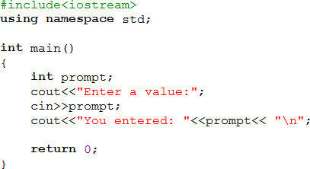

Here’s the program’s output:

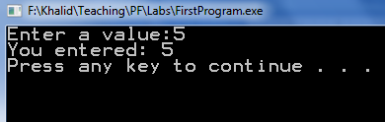

**Example 2.5:** This program illustrates integer addition. Also note the syntax necessary for the use of ***cin***.

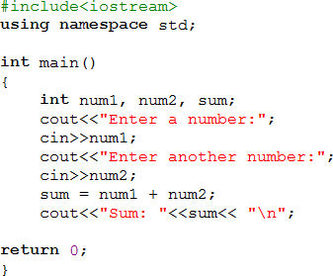

Here’s the program’s output:

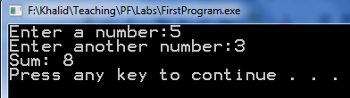

**Example 2.6:** This program illustrates more examples of ***cin*** and ***cout*** statements.

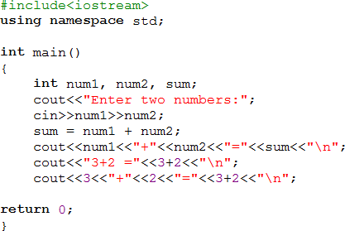

Here’s the program’s output:

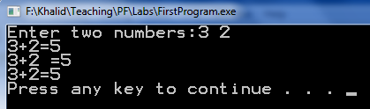

### Lab Exercise:

**Exercise 2.1**: Write a program to display:

Your name:

Your ID:

Your Course name:

**Exercise 2.2:** Write a program that prints the following diagram using ***cout*** statement.

* * * * * * * * *

* *

* *

* * * * * * * * *

### Home Work:

Write a program that take six subjects marks from user and display the sum of all marks.

Write a program to calculate and print the area of circle where as radius is equals to 3.